**Power School Parent Portal will be open to view schedules after the tenth day of classes.**

**To view your schedule**

* Students can see schedule by going to [my.ncedcloud.org](https://ucps-my.sharepoint.com/personal/kim_fisenne_ucps_k12_nc_us/Documents/Desktop/PRHS%2018-22/my.ncedcloud.org)
* Parents should Log in to Power School (Go to PRHS, QuickLinks, then choose “PowerSchool Parent Portal”), **however, this option is not available until after the first 10 days of the semester.**
* On the left there are several tabs, choose “Grades & Attendance”.
* The schedule for the year for your child will appear.
* If you do not have your PowerSchool Parent Portal account set up, you can email [laurie.lawrence@ucps.k12.nc.us](mailto:laurie.lawrence@ucps.k12.nc.us) to request access.

**Understanding your schedule**

T1,T2,T3 are the three grading periods that make up Semester1. This indicates that the course listed in this row is a Semester 1 course.

T4,T5,T6 are the three grading periods that make up Semester2. This indicates that the course listed in this row is a Semester 2 course.

Example schedule:

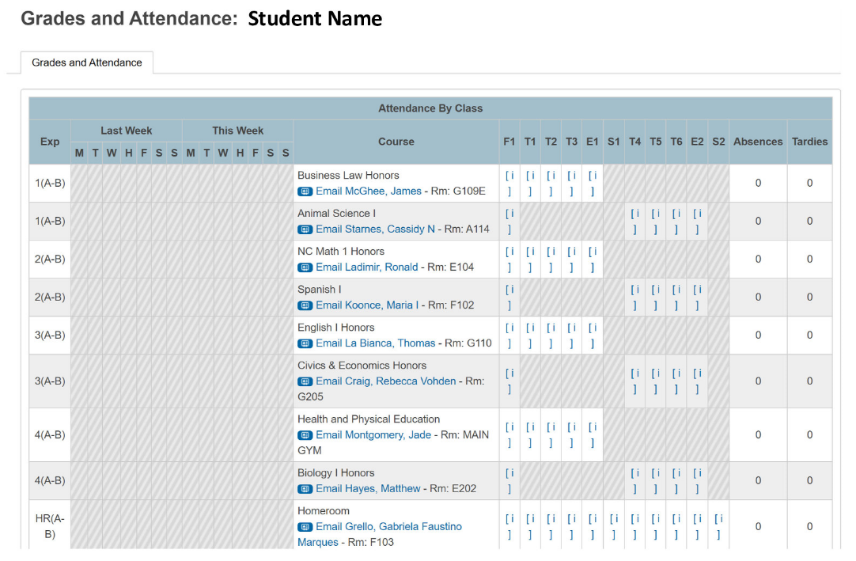

This column tells you the period of the day

1(A-B) means first period every day.

1(A) would mean this class is first period, on A days.

1(B) would mean this class is first period, on B days.

* + PRHS has some classes taught on an A/B day. In a traditional school year these classes meet every other day for the full period. An Aday/Bday calendar will be posted.
  + “Virtual Section” under courses means that the student registered for an online class through UCVirtual, NCVPS or CCP (community college). You can contact your counselor if you do not remember the course you registered for. Students are required to take their online courses at our school in the distance learning lab.

Additional Information for ALL students:

* All students are scheduled in “Homeroom”. In a traditional school year students meet with an Advisor during this time to focus on Career/College/Leadership/Life-Ready Learning.
* “Please See Your Counselor” is listed if you have an open spot in your schedule that period and need to contact your counselor by email or phone to choose a course.
* The link for schedule correction requests will appear on our PRHS website staring Monday 8/21. Requests will only be considered if your schedule has a class you already passed on it, a course you don’t meet the pre-requisites for, or you are missing a course needed to graduate.